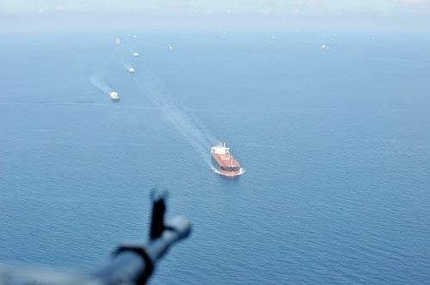

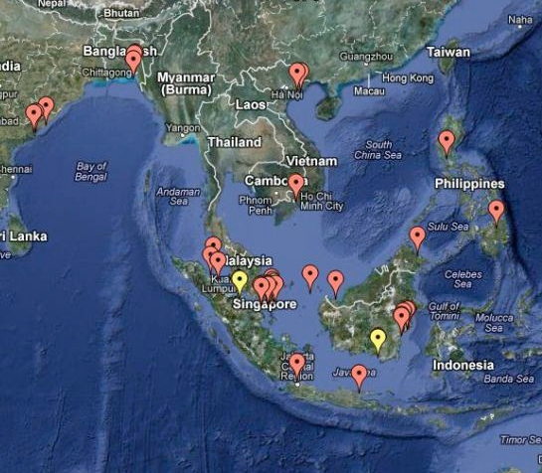
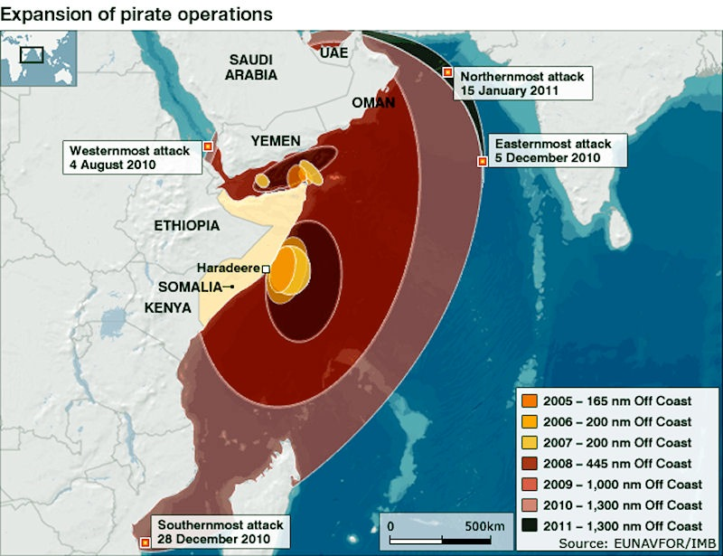


Global Piracy Report
Detailed Weekly Piracy Report and On - The - Ground Analysis Focusing
on Somalia, the Gulf of Guinea, Southeast Asia and South America
Summary (June 16 - 22, 2014 - Week 25; Edition 42)
List of Incidents at Sea for this Reporting Period
Gulf of Guinea/West Africa: No incidents reported during this period.
Somalia-Indian Ocean: No incidents reported during this period.
Southeast Asia: One late reported hijack; two incidents and one late reported incident.
South America: No incidents reported during this period.

North America: No current incidents to report
Central America-Caribbean: No current incidents to report
Atlantic Ocean Area: No current incidents to report
Northern Europe-Baltic: No current incidents to report
Mediterranean-Black Sea: No current incidents to report
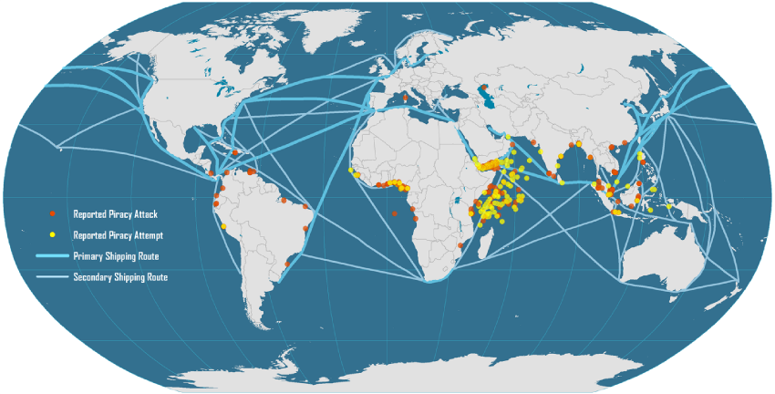

SOMALIA
At Sea
Hijacks:
- None reported during this period.
Unsuccessful Attacks/Robberies:
- None reported during this period.
Suspicious Activity:
- None reported during this period.

Weather Analysis
- Northern Arabian Sea – Southwest winds of 20 – 55 knots and seas of 12 – 15 feet.
- Extended Forecast – Southwest winds of 20 – 25 knots and seas of 8 – 10 feet.

- Gulf of Oman – Northwest winds of 10 – 15 knots and seas of 2 – 4 feet in the western section of the Gulf; with northwest winds of 10 – 15 knots and seas of 4 – 6 feet in the eastern section of the Gulf.
- Extended Forecast – West-northwest winds of 10 – 15 knots and seas of 2 – 4 feet in the western section of the Gulf; in the eastern section of the Gulf, winds will be southwesterly at 10 – 15 knots with seas of 4 – 6 feet.

- Gulf of Aden – Southwest winds of 15 – 20 knots and seas of 2 – 4 feet in the western section of the Gulf; with southwest winds of 15 – 20 knots and seas of 4 – 6 feet in the eastern section of the Gulf.
- Extended Forecast – Southwest winds of 15 – 20 knots and seas of 2 – 4 feet in the western section of the Gulf; in the eastern section of the Gulf, winds will be southwesterly at 15 – 20 knots with seas of 2 – 4 feet.

- Somali Coast – Southwest winds of 25 – 30 knots and seas of 8 – 10 feet; with southwest winds of 20 – 25 knots and seas of 8 – 10 feet in the vicinity of the Horn of Africa.
- Extended Forecast – Southwest winds of 25 – 30 knots, gusting to 35 knots, and seas of 13 – 15 feet with southwest winds of 20 – 25 knots and seas of 8 – 10 feet in the vicinity of the Horn of Africa.

- Central African Coast/Indian Ocean – South-southeast winds of 15 – 20 knots and seas of 4 – 6 feet.
- Extended Forecast – Southeast winds of 15 – 20 knots and seas of 9 – 12 feet.

- Mozambique Channel – Southerly winds of 10 – 15 knots and seas of 4 – 6 feet in the northern Channel; with southerly winds of 10 – 15 knots and seas of 4 – 6 feet in the southern Channel.
- Extended Forecast – Southeast winds of 10 – 15 knots and seas of 4 – 6 feet in the northern Channel; with southeast winds of 10 – 15 knots and seas of 4 – 6 feet in the southern Channel.

- Surface Currents – The northern Arabia Sea and Gulf of Aden currents are variable with most areas having an average speed of 1 knot. The Mozambique Channel currents are variable having an average speed of 2 knots. Currents speeds along the Somali basin are northeasterly averaging between 1 – 2 knots.

- Synoptic Discussion – The Southwest Monsoon influences the weather in the region. Weak shamal conditions persist for the next 12 – 24 hours, as high pressure situated over Saudi Arabia interacts with thermal lows across the region. Expect northwesterly winds, clear to partly cloudy skies, and reduced visibility due to blowing dust.

Sea Conditions for the Following Week

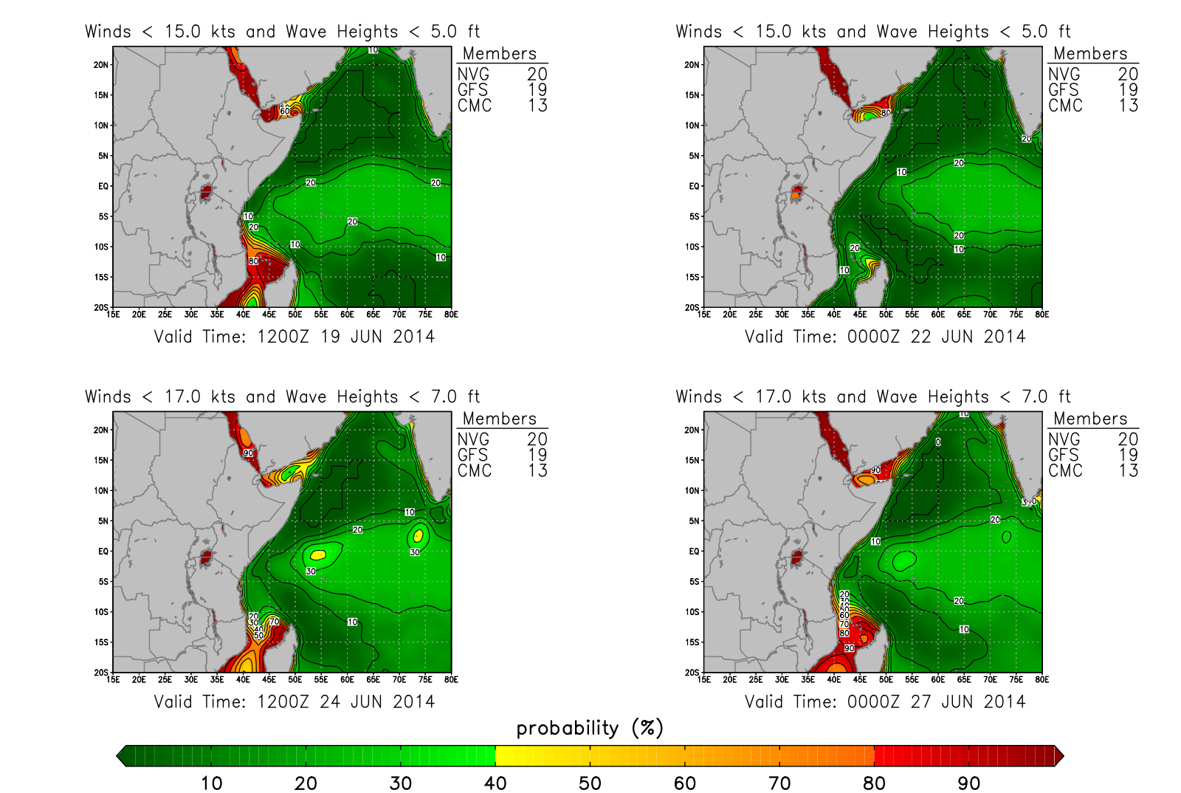

*** In this graphic, the green shading represents a reduced likelihood of small boats and skiffs operation in the area due to harsh sea conditions, while the red indicates a higher likelihood of favorable sea conditions for skiffs and smaller boats ***

On the Ground Analysis
- 21 June 2014 – A Somali journalist was killed in Mogadishu Saturday after a bomb, believed to have been attached to his car, was remotely detonated. The victim, prominent journalist Yusuf Keynan, was working with Mustaqbal radio, which is a private Mogadishu FM station. He also contributed to the Nairobi, Kenya-based UN humanitarian radio, Ergo. Somali police official Abdi Garane, confirmed the attack, stating, “it was a local journalist who was targeted in the attack. The bomb attached under the seat of his car went off, leaving him dead.” Somali security forces have sealed off the area in order to investigate the incident. While there was no immediate claim of responsibility, in recent months, Mogadishu has been hit by a string of attacks that have been carried out by al-Shabaab militants. In the past, journalists have been targeted by the militant group. Keynan was the second journalist to be killed in Mogadishu this year. Saturday’s attack came days after a student doctor was killed, and seven others wounded, in a bombing at Keysaney hospital in the northern area of Mogadishu. That attack also involved a bomb being attached to a car.
- 18 June 2014 – Eyewitnesses reported Wednesday that a bomb, hidden in a doctor’s car, has exploded in a hospital parking lot in the Somali capital, killing the doctor and wounding seven others. The remotely detonated bomb exploded as the doctor was leaving the hospital after completing a night shift. It is unknown whether militants were specifically targeting the doctor. The explosion, which is a rare attack that targeted health facilities in the war-torn country, occurred at the Keysaney Hospital, a facility that is run by the Somali Red Crescent Society and the International Committee of the Red Cross (ICRC). The 65-bed surgical referral hospital opened in 1992 and has been treating casualties of Somalia’s 20-year war. According to the ICRC, at the height of violence in the capital city in 2011, Keysaney treated nearly 2,000 patients with war. Almost 30,000 patients with weapons-related injuries, including many women and children, have also received treatment at the hospital. No one immediately claimed responsibility for the attack. While authorities in the capital city suspected al-Shabaab militants to be behind the attack, the militant group has rarely attacked health facilities.

Regional Reporting
- 20 June 2014 – In the wake of recent terror attacks, the Kenyan government on Friday urged people to watch the World Cup games at home rather than in public places. In a statement, the interior ministry stated “where possible, Kenyans are strongly advised to watch the World Cup matches from the comfort of their homes instead of crowded and unprotected open places,” adding “although the government has beefed up security in all parts of the country, bar and restaurant owners are at the same time notified to maintain high alert in their areas of operation….This will ensure that bar and restaurant patrons are safe from criminals who may try to take advantage of the World cup to perpetrate acts of criminality and violence.” On Sunday night, gunmen raided the coastal town of Mpeketoni, which is situated near the tourist island of Lamu, and killed fifty people. The attack came as some people in the town were watching a World Cup Match. A further nine people were killed in another attack in a nearby village the following night.
- 19 June 2014 – On Friday, US officials confirmed that they were evacuating some of its Kenyan embassy staff due to security risks in the wake of attacks, which have left dozens dead. According to the US State Department, travel restrictions have been put into place for government personnel and “based on the recent changes in Kenya’s security situation, the embassy is also relocating some staff to other countries.” Despite the evacuations however, the Nairobi-based embassy will “remain open for normal operations.” Over the past few weeks, the State Department has warned US citizens of the risks of travelling to the African country, and has urged those already there to “evaluate their personal security situation in light of continuing and recently heightened threats from terrorism and the high rate of violent crime in some areas,” adding that “the US government continues to receive information about potential terrorist threats aimed at US, Western and Kenyan interests in Kenyan” and “although the pursuit of those responsible for previous activities continues, many of those involved remain at large and still operate in the region.”
- Meanwhile interior ministry and a military source indicated Thursday that Kenyan security forces killed five people suspected of being involved in massacres that occurred earlier this week in the country’s coastal Lamu region. In a statement released early Thursday, the ministry stated that there were five “suspected attackers shot dead while escaping,” and that three AK-47 assault rifles as well as ammunition were recovered at the scene. A senior Lamu county official confirmed that the Kenyan army had been deployed in the area following Sunday night’s massacre in Mpeketoni, in which around fifty people were killed, and a separate attack, in a nearby village the following night, in which officials say nine people died. According to Benson Maisori, Lamu county’s deputy commissioner, “there was a heavy operation in the area of Badahai in Lamu county. The government deployed soldiers in that area in the morning. A military source also confirmed that the five were killed by soldiers but that other suspected attackers had escaped. Reports from survivors and witnesses of the attack on Mpeketoni say that the group numbered up to fifty militants.
- 18 June 2014 – Kenya’s police chief announced Wednesday that Kenyan police have arrested “several” suspects in connection with twin massacres on the coast in which at least sixty people were killed. According to police chief David Kimaiyo, “we have arrested several suspects in connection to Mpeketoni incident including the owner and driver of one of the vehicles used by attackers,” adding “ more suspects, including leaders, are being interrogated.” Police chief Kimaiyo further noted that the police officer commanding the station in the town, Aden Ali, was “dismissed with immediate effect” and will be charge, adding that also being held by the police is “a suspect who was operating social media accounts purportedly used by al-Shabaab to claim responsibility.” The assault on the town of Mpeketoni late on Sunday and a nearby village the following night have left at least sixty dead and have been claimed by Somalia’s al-Shabaab, despite Kenyan President Uhuru Kenyatta blaming the attacks on local political networks.
- On Wednesday, just one day after Kenya’s president insisted that “local political networks” and not al-Shabaab were to blame for the latest attacks to be carried out in his country, the al-Qaeda-linked group repeated claims that they were responsible for two consecutive massacres in Kenya. In a news conference broadcast by al-Shabaab’s radio, the militant group’s military spokesman, Abdulaziz Abu Musab, repeated claims of the group’s responsibility for the two attacks, stating “the attack in Mpeketoni was ordered by the mujahedeen high command to retaliate for Kenya’s killing of Muslims in Somalia and Kenya…” according to the spokesman, al-Shabaab attackers “controlled the area of the battle zone for 10 hours” after entering on Sunday night before withdrawing. He also indicated that twenty people were killed in an attack the following night in a nearby village. Kenyan officials however have reported that fifteen people were killed. During the news conference, the spokesman noted that “fighting against our enemies in Kenya will continue,” adding “we are calling on the Muslims in Kenya to fight for their dignity as there is no neutral middle ground now…” The recent remarks made by Kenya’s president, which dismissed al-Shabaab’s claims of responsibility for the two latest attacks, also come at a time when the Kenyan government is increasingly coming under attack for its inability of being able to protect its citizens and prevent the militant group from carrying out attacks. Last month, al-Shabaab warned that it was shifting its focus and would now concentrate more on Kenya.
- 17 June 2014 – Police officials confirmed Tuesday that at least fifteen people were killed in a new overnight attack near Kenya’s coast. Police indicated early Tuesday that gunmen, apparently part of the same group that massacred close to fifty people in the town of Mpeketoni overnight Sunday, attacked Poromoko village in the same region overnight on Monday, leaving fifteen people dead. Al-Shabaab’s military spokesman, Abdulaziz Abu Musab, confirmed the militant group’s responsibility stating “we carried out another attack last night. We killed 20 people, mainly police and Kenyan wildlife wardens. The commandos have been going to several places looking for military personnel,” adding “the commandos have fulfilled their duties and returned peacefully to their base.” The militant group has claimed responsibility for the two days of attacks and has stated that it will continue its campaign in the east African nation. It currently remains unknown whether the attackers are still in Kenya or whether they have driven back across the Somali border, which is located around 100 kilometers (60 miles) north. Kenyan police spokeswoman Zipporah Mboroki confirmed the attack however local police and a country official are reporting that at least fifteen people were killed as officers are still attempting to access the scene. Local authorities have also reported that the militants jammed a telecommunication system before the killings in order to prevent villagers from sounding the alarm.
- Sources have reported that at least twelve women were abducted during the latest attack to be carried out by suspected Islamist militants on Kenya’s coast. Local police have reported that at least fifteen people were killed during an overnight raid on two villages near the town of Mpeketoni, where on Sunday at least 49 people died during a raid on hotels and a police station. While al-Shabaab confirmed its responsibility in the attacks on Tuesday, stating that it was revenge for the presence of Kenyan troops in Somali and for the killing of Muslims, Kenya’s president has dismissed these claims, stating that the attacks were planned by “local political networks.” On Tuesday, during an address to the nation, President Uhuru Kenyatta stated “the attack in Lamu was well planned, orchestrated and politically motivated ethnic violence against the Kenyan community….This, therefore, was not an al-Shabaab terrorist attack. Evidence indicates local political networks were involved in the planning and execution of the heinous crime. This also played into the opportunist network of other criminal gangs.” Update (18 June 2014) – On Wednesday, Kenyan authorities denied reports that several women were kidnapped during the deadly militant attacks against the town of Mpeketoni and surrounding villages on the country’s coast. Several sources had initially reported that the attackers had also abducted twelve women after having killed at least sixty people in two consecutive nights of carnage. However on Wednesday, Kenya’s police chief David Kimaiyo, who is currently visiting the area, stated “there were not attacks involving women, and therefore those are false reports.” Another official, assistant county commissioner Benson Maisori, has indicated that investigations have so far shown that the attackers only targeted men, stating “there were no such abduction cases of women. What happened is that the attackers went from house to house picking men only. They weren’t targeting women at all…,” adding that in one village, the gunmen kidnapped eight men who were later found dead. The Kenyan Red Cross, which has been collecting information on those reported missing, has indicated that so far they have “no evidence” to substantiate the reports that women were kidnapped. According to Kenyan Red Cross Secretary General Abbas Gullet, “the missing persons…either went into hiding or in one way or another couldn’t be traced. But we can’t deny or confirm any abductions.” The Secretary General also noted that the Red Cross currently has nine people who are still listed as missing, down from more than fifty missing persons reports it was treating on Tuesday. A group of heavily armed gunmen attacked Mpeketoni, which is located close to the tourist island of Lamu, late on Sunday, with eyewitnesses later reported that they singled out non-Muslim men who were later executed.
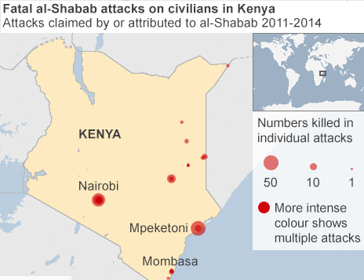
- In the wake of two attacks carried out by Islamist militants over the past few days, Kenya’s security chiefs are under increasing pressure to resign, with the government now being accused of ignoring an increasingly sophisticated threat that is coming from Somalia’s al-Qaeda-linked al-Shabaab. On Tuesday, the Islamist group confirmed that its fighters had carried out two nights of carnage, that have left close to 60 Kenyans dead in a town and villages located along Kenya’s coast, before returning “peacefully to their base” without a single arrest being made. With warnings to tourists that further attacks will occur, Kenyan’s are increasingly criticizing the government’s lack of response to the threat, which has been growing since the country deployed troops to Somalia in 2011. The Law Society of Kenya has stated that the country’s security forces were either “incompetent or incapacitated,” and has called for the resignation of police chief David Kimaiyo and the increasingly unpopular Interior Minister Josephe Ole Lenku. Many believe that the lapse in security is due to Kenya’s leaders being more focused on domestic politics, as well as fighting crimes against humanity charges at the International Criminal Court (ICC) for President Uhuru Kenyatta and his deputy William Ruto. According to one source, “despite the clear danger, Kenya’s security has taken its eye off the ball, partly distracted by issues such as domestic politics and the ICC, but also a sheer head in the sand approach to the scale of the problem they face.” Coupled with this, many experts believe that Kenya has its own dangerous cells of homegrown extremists who are adding to the problem. Although they are independent to al-Shabaab, they share a similar ideology. In turn, heavily handed police operations on the coast have enraged many, as have the round-ups in the capital of ethnic Somalis and Somali refugees, with Muslim communities also accusing the government of extra-judicial killings of radical clerics. Kenya’s National Commission on Human Rights firmly believes that “the state’s response to insecurity is ad hoc, and the operations put in place have violated human rights.” While early attacks were largely confined to small ambushes, homemade bomb or hand grenades, and targeted poor areas of Nairobi and Mombasa, as well as the remote northeastern border region with Somalia, attacks are now increasingly being sophisticated, with militants outsmarting security forces, which are riven by divisions within the multiple agencies. According to one diplomat, “the Shabaab threat is changing and morphing, showing a growing sophistication as they get closer and interact more with al-Qaeda,” adding that the “nature of their attacks are constantly changing.” The diplomat further noted that an unexploded car bomb found in the port city of Mombasa earlier this year was “of the level of sophistication” not seen before in the region.” Although similar concerns were raised after last year’s attack on the Westgate shopping center in Nairobi there have been minimal security changes made over the past year.
- 16 June 2014 - In what appears to be a clear sign that al-Shabaab’s recent statement of moving the war to Kenya is now becoming a reality, at least forty-nine people were killed on Sunday after unidentified gunmen attacked hotels and a police station in a Kenyan coastal town. Sunday’s attack is the deadliest incident to occur in Kenya since last year’s Westgate shopping center siege. Late Sunday, around 50-heavily armed gunmen attacked a busy coastal town, opening fire from two minibuses. Witnesses in the town of Mpeketoni, which is located on the mainland near Lamu island, a well-known tourist resort, reported Monday that gun battles, which began around 8:00 PM (1700 GMT), lasted for several hours on Sunday, while several buildings were set on fire. Witnesses have reported that a police station, a bank and two hotels were attacked, however officials have not confirmed the extent of the attack. The latest attack to hit Kenya came as cafes and bars were beginning to fill up with people expected to watch the World Cup game. According to Kenyan army spokesman Major Emmanuel Chirchir, the gunmen entered the western town of Mpeketoni, a trading center on the main coastal road located around 100 kilometers (60 miles) from the border with Somalia, and began “shooting people around in town.” An investigation has been launched with “surveillance aircraft already airborne,” searching for the attackers, who are believed to have fled into a nearby forest. While unconfirmed reports had initially indicated that the raid may have been linked to a land dispute between rival communities in the remote area, early on Monday Major Chirchir stated that the attackers are “likely to be al-Shabaab.” This statement was confirmed later Monday when a statement released by the militant group indicated that the attack was revenge for the “Kenyan government’s brutal oppression of Muslims in Kenya through coercion, intimidation and extrajudicial killings of Muslim scholars.” The group also condemned the “Kenyan military’s continued invasion and occupation of our Muslim lands and the massacre of innocent Muslims in Somalia,’ adding “to the tourists visiting Kenya we say this: Kenya is now a war zone and as such any tourists visiting the country do so at their own peril.” The latest attack in Kenya comes just weeks after al-Shabaab’s most senior commander, Fuad Mohamed Khalaf, released a radio broadcast, urging his fighters to strike Kenya. Rising tensions in Kenya, coupled with on going militant threats and attacks have prompted a number of travel advisories to be issued by countries including the United States and United Kingdom. Following new warnings of terror attacks from Britain’s Foreign Office, hundreds of British tourists were evacuated last month from beach resorts near Kenya’s port city of Mombasa. Earlier this week, Britain released additional warnings to citizens in several East African nations, including Kenya, Djibouti, Ethiopia and Uganda, all of which have troops deployed in Somalia. According to Britain’s Foreign Office, there is currently a heightened threat of attacks at public screenings of the World Cup games. With the on going World Cup football tournament set to end on July 13, further attacks on bars and cafes showcasing the games are highly likely to occur. While Kenya has suffered numerous militant attacks since deploying troops to neighboring Somalia to combat the al-Qaeda-linked al-Shabaab in 2011, this is the most deadly attack in the country since at least sixty-seven people were killed during a siege by al-Shabaab fighters at Nairobi’s Westgate shopping center last September.

Map
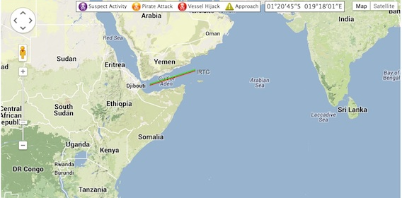

GULF OF GUINEA
At Sea
Hijacks:
- None reported during this period.
Unsuccessful Attacks/Robberies:
- None reported during this period.

Weather Analysis
- Gulf of Guinea – South-southwest winds of 15 - 20 knots and seas of 3 – 5 feet.
- Extended Forecast – Southerly winds of 15 - 20 knots and seas of 3 – 5 feet.

- Synoptic Discussion – The Gulf of Guinea will be impacted by partly to mostly cloudy skies, with isolated thunderstorms.

SOUTHEAST ASIA
At Sea
Hijacks:
- 14 June 2014 (Late Report) – Honduras-flagged, Japanese-owned product tanker, Ai Maru, underway to the Gulf of Thailand was attached by seven armed pirates in three speedboats at 2030 LT in position 02:06.90N – 104:39.80E, South China Sea. The pirates, who were armed with knives and pistols, boarded the vessel, tied up the crew and locked them in a room. They damaged the communications equipment and stole the crew members personal belongings. They fled as a maritime forces, which was deployed in response to the boarding, approached the vessel.

Unsuccessful Attacks/Robberies:
- 17 June 2014 – While at anchor, Panama-flagged bulk carrier, Bulk Ecuador, duty A/B on rounds noticed the padlock locker broken and sighted four robbers armed with knives at 1800 LT in position 03:57N – 098:46E, Belawan anchorage, Indonesia. Duty AB immediately informed the C/O, who raised the alarm and alerted the crew members. Upon hearing the alarm, the robbers escaped. Upon inspection, ship’s stores and property were found stolen.
- Owners of an Indonesia – flagged product tanker, Arsenal, reported having lost communication with the vessel carrying MOGAS with a crew of twelve Indonesians. Vessel’s last known position at 0045 UTC was 01:31N – 104:29E, approximately 12 nautical miles off Johor, Malaysia, in South China Sea. Arsenal was accompanied by a tug named Pawai.
- 9 June 2014 (Late Report) – Malaysia-flagged tug boat, Manyplus 12, towing barge, Hub 18, departed Sibu, Sarawak for Port Klang. Vessels scheduled to arrive 13 June, however have not appeared. Shipping company had last contact with the Master of the vessel on June 9 at around 1210 LT in position 02:06.58N – 108:37.05E, approximately 61.37 nautical miles west of Tanjung Datu, Sarawak, Malaysia. Tug boat with 11 crew embers, and barge with 138 containers.

Suspicious Activity:
- None reported during this period.

SOUTH AMERICA
At Sea

Hijacks:
- None reported during this period.
Unsuccessful Attacks/Robberies:
- None reported during this period.

About MS Risk

MS Risk is a privately owned company domiciled in the Isle of Man. It is underwritten by a syndicate of Lloyd’s of London for special risks case management in all jurisdictions. It also acts as retained advisors to syndicates in the Lloyd’s of London specialty risk insurance markets: kidnap for ransom, extortion, hijack, illegal detention, illegal war tax, malicious product tamper, terrorism, political and war risk.
MS Risk is always mindful and compliant to legislation and guidelines on the use of private security services including, but not limited to the US FCPA (1977), UK Bribery Act (2010), Canadian Bill C-48 (2007), ASX 8 Corporate Governance Principles, and the World Bank/IFC Voluntary Principles on the Use of Government and Private Security Forces. MS Risk is a signatory of the Swiss government’s International Code of Conduct. It is transparent and compliant to market expectations on legal and ethical conduct in the performance of services.
MS Risk has a dedicated team of researchers, a 24/7 hotline service and a pool of trained and experienced consultants to support client needs.
MS Risk supports clients in a variety of business sectors with the following services:

  - Security Consulting
    - Risk assessments and intelligence reporting
    - Planning and management
    - Due diligence and investigations.

  - Project Management
    - Interim security
    - Training
    - Special assignments

  - Crisis Response
    - Crisis management
    - Business continuity management
    - Hostile operations support to commercial interests

  - Virtual Security Director service for clients lacking a full time security executive.

References are always available.
More information is found at www.msrisk.com
24 hr Contact Information:
Email: operations@msrisk.com
Telephone: +44 207 754 3555

About JLT
At JLT Specialty, we believe in doing things differently.
When it comes to advising ship owners and operators, shipyards and ports and terminal operators we take the time to really understand your world, your people and your very particular challenges. We work closely with you to consider your business both today and tomorrow, and to explore all the variables which may impact on it.
We work with yourselves, our network and the market to deliver a solution which is always tailored to your specific needs and always competitive and comprehensive.
Because of this our clients trust us. They have total confidence that the vital elements of their operations are covered, enabling their businesses to be even more ambitious and surpass expectations. This is why we now place insurance for more than 6,000 vessels, including one third of the world gas fleet and we handle more than USD350m marine insurance premium.
We know how we work makes us different. It’s quite a claim but we’re driven to deliver on it every single day.
JLT Specialty Limited (JLT Specialty) is a member of the Jardine Lloyd Thompson Group of companies. Jardine Lloyd Thompson Group plc is an international group of Risk Specialists and Employee Benefits Consultants. Listed on the FTSE 250 index of the London Stock Exchange, Jardine Lloyd Thompson Group plc is one of the largest companies of its type in the world.
For more information, visit our website: www.jltgroup.com.
Disclaimer:
This report has been produced by MS Risk and has been published for the benefit of clients and prospects of JLT Specialty Limited. It is not legal advice and is intended only to highlight general issues relating to the subject matter which may be of interest and does not necessary deal with every important topic nor cover every aspect of the topics with which it deals. If you intend to take any action or make any decision on the basis of the content of this newsletter, you should first seek specific professional advice.

South Suite, Ragnall House, 18 Peel Road
Douglas, Isle of Man, IM1 4LZ

24 hr Global Contact: +44 207 754 3555
www.msrisk.com

Directors
S.J. Bingham, V.K. Prentice, P.O.J Tracy
Registered in the Isle of Man No. 007435V

